HUMAN HELP FOUNDATION MANAGEMENT SYSTEM

Software Requirements Specification

Version 1.0

01-11-2013

Prepared by:

Sufyan Ahmad bcs0111348

Muhammad Ali bcs01113306

Waqas Younas Bhatti bcs01113253

Umer Farooq bcs01113151

Submitted to:

**Ma’am Irum Noreen**

# Revision History

|  |  |  |  |
| --- | --- | --- | --- |
| **Date** | **Description** | **Author** | **Comments** |
| <date> | <Version 1> | <Your Name> | <First Revision> |
| 01-11-13 | 1.0 | KK Group |  |
|  |  |  |  |
|  |  |  |  |

# Document Approval

The following Software Requirements Specification has been accepted and approved by the following:

|  |  |  |  |
| --- | --- | --- | --- |
| **Signature** | **Printed Name** | **Title** | **Date** |
|  | <Your Name> | Lead Software Eng. |  |
|  |  |  |  |
|  |  |  |  |

Purpose:

The basic purpose of this document is to provide description and illustrate whole requirements and features of the foundation system. The document gives the detailed description of the both functional and non-functional Requirements proposed by the client.

Scope:

Product name: Human help foundation management system

This product will manage collection and distribution of funds in different sections according to their needs and requirements.

This product will provide us secure and easy way to collect and distribute funds of foundation.

Overview:

Rest of the SRS contains specific requirements, functional requirements, cases and non-functional requirements.

First of all we conduct a meeting with appropriate client and discuss about their requirements write it down on a document. we also discuss all features of the product which they want in product.

Definition acronym and abbreviation:

For Administrator : For user:

Monitor All records Donate

Transfer Funds Contact us

Write Foundation status Latest updates

Notification Feed back

Privacy settings Volunteer

Communication About us

References:

We use IEEE general recommended SRS template.

Scope and objective:

This product is only for specific foundation And it will keep all collection of records of Organization. The objective of this product is to provide secure ,reliable and efficient way to collect and distribution of funds.

Problem Statement:

There is a human help foundation. This foundation collects and distributes funds in different ways. There is no suitable, secure, and efficient way to manage organization funds properly.

General constraints:

Only Administrator can see, edit and delete funds records.

common people can see records but can’t edit or delete.

Visual studio 2012 or greater and SQL server 2012 or greater should support the product.

Assumptions and Dependencies:

Windows 7 or greater version in both modes 32/64 bit should support this product.

Specific Requirements:

Keep records of funds collection and distribution.

Which source it comes and where funds distribute with how much percentage.

Keep all records of donators.

Avoid funds to misuse.

Communication with donator and sub branches

## External Interface Requirements

### User Interfaces:

User interface should be user friendly.

### Hardware Interfaces:

Hard ware should be reliable.

Product should enable to take print of all records.

### Software Interfaces:

Visual studio 2012 or greater and SQL server 2012 or greater should be support this product.

### Communications Interfaces:

Product should be able to contact with donators and sub branches

Major Features:

Front page

Sign Up

Sign In

Privacy Settings

Funds transfer

total funds

International funds

National funds

Automatic fund transfer to sections with specific percentage

Education funds

Health and safety funds

Communication

Notification

Feed back

About us

Contact us

Scope & Limitations:

Provide a platform to user to donate the fund easily.

Provide a platform that Administrator should be able to manage and transfer the fund with percentage.

User can’t edit, delete and modify records.

Functional Requirements:

User can donate the funds.

User can give us a feedback.

User can apply for a volunteer.

User can contact with administrator.

Administrator can monitor all activities.

Administrator can share foundation latest updates.

Administrator can check all types of user feedback.

Administrator can set privacy settings.

Administrator can communication with donator and sub-branches.

**Uses cases**

|  |  |
| --- | --- |
| Use Case Name | Donate |
| Description | First user visits our site than he/she can donate funds online. |
| Primary Actor | Visitor |
| Secondary Actor | None. |
| Pre-Conditions | User has opened the site successfully. |
| Basic Flow | 1. User will open the site. 2. Open link of donate 3. User fills all fields of required information. |
| Post Conditions | |  | | --- | | User has successfully donated the fund. | |
| Alternative Flow | 1. Information provided not complete or incorrect. 2. Required format is not followed properly. |

|  |  |
| --- | --- |
| Use Case Name | Volunteer |
| Description | First user visits our site than he/she apply for volunteer |
| Primary Actor | Visitor |
| Secondary Actor | None. |
| Pre-Conditions | User has opened the site successfully. |
| Basic Flow | 1. User will open the site.  2.Open link of volunteer  3. User fills all fields of required information. |
| Post Conditions | |  | | --- | | User has successfully applied for volunteer. | |
| Alternative Flow | 4. Information provided not complete or incorrect.  5. Required format is not followed properly. |

|  |  |
| --- | --- |
| Use Case Name | About us |
| Description | First user visits our site than he/she can check about our information and activities of foundation. |
| Primary Actor | Visitor |
| Secondary Actor | None. |
| Pre-Conditions | User has opened the site successfully. |
| Basic Flow | User will open the site.  Open link of About us. |
| Post Conditions | None |
| Alternative Flow | none |

|  |  |
| --- | --- |
| Use Case Name | Feed back |
| Description | First user visits our site than he/she can give us feedback |
| Primary Actor | Visitor |
| Secondary Actor | None. |
| Pre-Conditions | User has opened the site successfully. |
| Basic Flow | 1. User will open the site. 2. Open link of feedback. 3. User fills all fields of required information. |
| Post Conditions | |  | | --- | | User has successfully give feedback. | |
| Alternative Flow | 1. Information provided not complete or incorrect. 2. Required format is not followed properly. |

|  |  |
| --- | --- |
| Use Case Name | Contact us |
| Description | First user visits our site than he/she can contacts us online and also check our contact no. |
| Primary Actor | Visitor |
| Secondary Actor | None. |
| Pre-Conditions | User has opened the site successfully. |
| Basic Flow | 1.User will open the site.  2.Open link of  3.User fills all fields of required information. |
| Post Conditions | |  | | --- | | User has successfully contact with us | |
| Alternative Flow | Busy |

**Use Case Model**

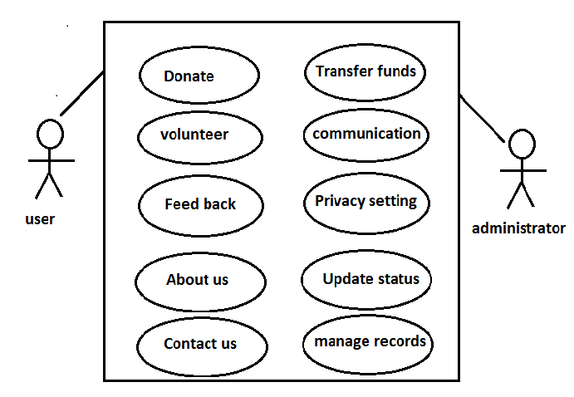

Non-Functional Requirements

## Performance:

The product should give high performance and efficient for user.

Reliability:

The product should be reliable with the passage of time.

### Availability:

This product should be easily accessible to all users at any time.

### Security:

Our project security should be high. Unauthorized person can’t edit or delete our information and data.

### Maintainability:

Our product is easily maintainable.

### Portability:

We can access our product at any place.